Unit – II

- Architecture of 8085Microprocessor:

FIG. Hardware Architecture of 8085
Control Unit
Generates signals within Microprocessor to carry out the instruction, which has been decoded. In reality causes certain connections between blocks of the microprocessor to be opened or closed, so that data goes where it is required, and so that ALU operations occur.
Arithmetic Logic Unit
The ALU performs the actual numerical and logic operation such as „addition, „subtraction, „ANDed, „ORed, etc. Uses data from memory and from Accumulator to perform arithmetic. Always stores result of operation in Accumulator.
Registers
The 8085/8080A-programming model includes six registers, one accumulator, and one flag register, as shown in Figure. In addition, it has two 16-bit registers: the stack pointer and the program counter. The 8085/8080A has six general-purpose registers to store 8-bit data; these are identified as B,C,D,E,H, and L as shown in the figure. They can be combined as register pairs - BC, DE, and HL - to perform some 16-bit operations. The programmer can use these registers to store or copy data into the registers by using data copy instructions.
Accumulator
The accumulator is an 8-bit register that is a part of arithmetic/logic unit (ALU). This register is used to store 8-bit data and to perform arithmetic and logical operations. The result of an operation is stored in the accumulator. The accumulator is also identified as register A.
Flags
The ALU includes five flip-flops, which are set or reset after an operation according to data conditions of the result in the accumulator and other registers. They are called Zero(Z), Carry (CY), Sign (S), Parity (P), and Auxiliary Carry (AC) flags. The most commonly used flags are Zero, Carry, and Sign. The microprocessor uses these flags to test data conditions.
For example, after an addition of two numbers, if the sum in the accumulator id larger than eight bits, the flip-flop uses to indicate a carry -- called the Carry flag (CY) – is set to one. When an arithmetic operation results in zero, the flip-flop called the Zero(Z) flag is set to one. The first Figure shows an 8-bit register, called the flag register, adjacent to the accumulator. However, it is not used as a register; five bit positions out of eight are used to store the outputs of the five flip-flops. The flags are stored in the 8-bit register so that the programmer can examiexamine these flags (dataconditions) by accessing the register through an instruction. These flags have critical importance in the decision-making process of the microprocessor. The conditions (set or reset) of the flags are tested through the software instructions. For example, the instruction JC (Jump on Carry) is implemented to change the sequence of a program when CY flag is set.
Program Counter (PC)
This 16-bit register deals with sequencing the execution of instructions. This register is a memory pointer. Memory locations have 16-bit addresses, and that is why this is a16-bit register.
The microprocessor uses this register to sequence the execution of the instructions. The function of the program counter is to point to the memory address from which the next byte is to be fetched. When a byte (machine code) is being fetched, the program counter is incremented by one to point to the next memory location
Stack Pointer (SP)
The stack pointer is also a 16-bit register used as a memory pointer. It points to a memory location in R/W memory, called the stack. The beginning of the stack is defined by loading 16-bit address in the stack pointer.
Instruction Register/Decoder
Temporary store for the current instruction of a program. Latest instruction sent here from memory prior to execution. Decoder then takes instruction and „decodes‟ or interprets the instruction. Decoded instruction then passed to next stage.
Memory Address Register
Holds address, received from PC, of next program instruction. Feeds the address bus with addresses of location of the program under execution.
Control Generator
Generates signals within microprocessor to carry out the instruction which has been decoded. In reality causes certain connections between blocks of the microprocessor to be opened or closed, so that data goes where it is required, and so that ALU operations occur.
Register Selector
This block controls the use of the register stack in the example. Just a logic circuit which switches between different registers in the set will receive instructions from Control Unit.
- 8085 SYSTEM BUS
Typical system uses a number of busses, collection of wires, which transmit binary numbers, one bit per wire. A typical microprocessor communicates with memory and other devices (input and output) using three busses: Address Bus, Data Bus and Control Bus.
Address Bus
One wire for each bit, therefore 16 bits = 16 wires. Binary number carried alerts memory to ‘open’ the designated box. Data (binary) can then be put in or taken out. The Address Bus consists of 16 wires, therefore 16 bits. Its "width" is 16 bits. A 16 bit binary number allows 216 different numbers, or 32000 different numbers, ie 0000000000000000 up to 1111111111111111. Because memory consists of boxes, each with a unique address, the size of the address bus determines the size of memory, which can be used. To communicate with memory the microprocessor sends an address on the address bus, eg 0000000000000011 (3 in decimal), to the memory. The memory the selects box number 3 for reading or writing data. Address bus is unidirectional, ie numbers only sent from microprocessor to memory, not other way.
Data Bus
Data Bus: carries ‘data’, in binary form, between μP and other external units, such as memory. Typical size is 8 or 16 bits. Size determined by size of boxes in memory and μP size helps determine performance of μP. The Data Bus typically consists of 8 wires. Therefore, 28 combinations of binary digits. Data bus used to transmit "data", ie information, results of arithmetic, etc, between memory and the microprocessor.
Bus is bi-directional. Size of the data bus determines what arithmetic can be done. If only 8 bits wide then largest number is 11111111 (255 in decimal). Therefore, larger number have to be broken down into chunks of 255. This slows microprocessor. Data Bus also carries instructions from memory to the microprocessor. Size of the bus therefore limits the number of possible instructions to 256, each specified by a separate number.
Control Bus
Control Bus are various lines which have specific functions for coordinating and controlling uP operations. Eg: Read/NotWrite line, single binary digit. Control whether memory is being ‘written to’ (data stored in mem) or ‘read from’ (data taken out of mem) 1 = Read, 0 = Write. May also include clock line(s) for timing/synchronising, ‘interrupts’, ‘reset’ etc. Typically μP has 10 control lines.
Cannot function correctly without these vital control signals.
The Control Bus carries control signals partly unidirectional, partly bi-directional. Control signals are things like "read or write". This tells memory that we are either reading from a location, specified on the address bus, or writing to a location specified. Various other signals to control and coordinate the operation of the system.
Modern day microprocessors, like 80386, 80486 have much larger busses. Typically 16 or 32 bit busses, which allow larger number of instructions, more memory location, and faster arithmetic. Microcontrollers organized along same lines, except: because microcontrollers have memory etc inside the chip, the busses may all be internal. In the microprocessor the three busses are external to the chip (except for the internal data bus). In case of external busses, the chip connects to the busses via buffers, which are simply an electronic connection between external bus and the internal data bus.
- INSTRUCTION SET CLASSIFICATION
An instruction is a binary pattern designed inside a microprocessor to perform a specific function. The entire group of instructions, called the instruction set, determines what functions the microprocessor can perform. These instructions can be classified into the following five functional categories: data transfer (copy) operations, arithmetic operations, logical operations, branching operations, and machine-control operations.
Data Transfer (Copy) Operations:
This group of instructions copy data from a location called a source to another location called a destination, without modifying the contents of the source. In technical manuals, the term data transfer is used for this copying function. However, the term transfer is misleading; it creates the impression that the contents of the source are destroyed when, in fact, the contents are retained without any modification.
The various types of data transfer (copy) are listed below together with examples of each type:
Types | Examples
1. Between Registers | 1. Copy the contents of the register B into  register D.
2. Specific data byte to a register or a  memory location. | 2. Load register B with the data byte 32H.
3. Between a memory location and a  register. | 3. From a memory location 2000H to register  B.
4. Between an I/O device and the  accumulator. | 4.From an input keyboard to the  accumulator.

Arithmetic Operations:
These instructions perform arithmetic operations such as addition, subtraction, increment, and decrement.
Addition - Any 8-bit number, or the contents of a register or the contents of a memory location can be added to the contents of the accumulator and the sum is stored in the accumulator. No two other 8-bit registers can be added directly (e.g., the contents of register B cannot be added directly to the contents of the register C). The instruction DAD is an exception; it adds 16-bit data directly in register pairs.
Subtraction - Any 8-bit number, or the contents of a register, or the contents of a memory location can be subtracted from the contents of the accumulator and the results stored in the accumulator. The subtraction is performed in 2's compliment, and the results if negative, are expressed in 2's complement. No two other registers can be subtracted directly.
Increment/Decrement - The 8-bit contents of a register or a memory location can be incremented or decrement by 1. Similarly, the 16-bit contents of a register pair (such as BC) can be incremented or decrement by 1. These increment and decrement operations differ from addition and subtraction in an important way; i.e., they can be performed in any one of the registers or in a memory location.
Logical Operations:
These instructions perform various logical operations with the contents of the accumulator.
AND, OR Exclusive-OR - Any 8-bit number, or the contents of a register, or of a memory location can be logically ANDed, Ored, or Exclusive-ORed with the contents of the accumulator. The results are stored in the accumulator.
Rotate- Each bit in the accumulator can be shifted either left or right to the next position.
Compare- Any 8-bit number, or the contents of a register, or a memory location can be compared for equality, greater than, or less than, with the contents of the accumulator.
Complement - The contents of the accumulator can be complemented. All 0s are replaced by 1s and all 1s are replaced by 0s.
Branching Operations:
This group of instructions alters the sequence of program execution either conditionally or unconditionally.
Jump - Conditional jumps are an important aspect of the decision-making process in the programming. These instructions test for a certain conditions (e.g., Zero or Carry flag) and alter the program sequence when the condition is met. In addition, the instruction set includes an instruction called unconditional jump.
Call, Return, and Restart - These instructions change the sequence of a program either by calling a subroutine or returning from a subroutine. The conditional Call and Return instructions also can test condition flags.
Machine Control Operations:
These instructions control machine functions such as Halt, Interrupt, or do nothing
- 8085 ADDRESSING MODE:
Addressing modes are the manner of specifying effective address. 8085 Addressing mode can be classified into:
1 - Direct Addressing Mode: the instruction consist of three byte, byte for the opcode of the instruction followed by two bytes represent the address of the operand
Low order bits of the address are in byte 2
High order bits of the address are in byte 3
Ex: LDA 2000h
This instruction load the Accumulator is loaded with the 8-bit content of memory location [2000h]
2 - Register addressing mode: The instruction specifies the register or register pair in which the data is located .
Ex: MOV A,B
Here the content of B register is copied to the Accumulator.
3 - Register indirect addressing mode: The instruction specifies a register pair which contains the memory address where the data is located.
Ex. MOV M , A
Here the HL register pair is used as a pointer to memory location. The content of Accumulator is copied to that location
4- Immediate addressing mode: The instruction contains the data itself. This is either an 8 bit quantity or 16 bit (the LSB first and the MSB is the second)
Ex: MVI A , 28h LXI H , 2000h
First instruction loads the Accumulator with the 8-bit immediate data 28h Second instruction loads the HL register pair with 16-bit immediate data 2000h.
- MULTIPLEXER
A Multiplexer or Mux is a device that has many inputs and a single output. The selected line decides which i/p is connected to the o/p, and also increases the amount of data that can be sent over an n/w within a certain time. A multiplexer is also called as a data selector. The best example of non-electronic circuit of the multiplexer is a single-pole, multi-position switch, which is generally used in many electronics circuits. The main purpose of mux is to perform high speed switching and is constructed by a basic electronic components. These are accomplished by handling both analog and digital applications. In analog applications, these are made up of transistor switches and relays, whereas in digital applications, these are made up of logic gates. When the mux is used in digital applications, it is called as a digital multiplexer.
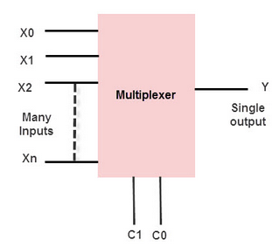

4-to-1 Multiplexer
The 4X1 multiplexer comprises 4-input bits, 1- output bit, and 2- control bits. The four input bits are namely 0, D1, D2 and D3, respectively; only one of the input bit is transmitted to the output. The o/p ‘q’ depends on the value of control input AB. The control bit AB decides which of the i/p data bit should transmit the output. The following figure shows the 4X1 multiplexer circuit diagram using AND gates. For example, when the control bits AB =00, then the higher AND gate are allowed while remaining AND gates are restricted. Thus, data input D0 is transmitted to the output ‘q”
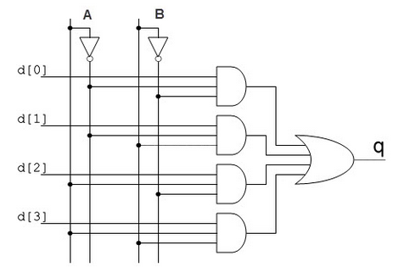
If the control input is changed to 11, then all gates are restricted except the bottom AND gate. In this case, D3 is transmitted to the output and q=D0. If the control input is changed to AB =11, all gates are disabled except the bottom AND gate. In this case, D3 is transmitted to the output and q = D3.The best example of 4X1 multiplexer is IC 74153. In this IC, the o/p is same as the i/p. Another example of 4X1 multiplexer is IC 45352. In this IC, the o/p is the compliment of the i/p

Applications of Multiplexers
A Multiplexer is used in various applications wherein multiple data can be transmitted using a single line.
Communication System – A Multiplexer is used in communication systems, which has a transmission system and also a communication network. A Multiplexer is used to increase the efficiency of the communication system by allowing the transmission of data, such as audio & video data from different channels via cables and single lines.
Computer Memory – A Multiplexer is used in computer memory to keep up a vast amount of memory in the computers, and also to decrease the number of copper lines necessary to connect the memory to other parts of the computer.
Telephone Network – A multiplexer is used in telephone networks to integrate the multiple audio signals on a single line of transmission.
Transmission from the Computer System of a Satellite:
A Multiplexer is used to transmit the data signals from the computer system of a satellite to the ground system by using a GSM communication.

DE-MULTIPLEXER
A demultiplexer is a device, that has one input and multiple output lines which is used to send a signal to one of the various devices. The most prominent distinction between a multiplexer and demultiplexer is that a multiplexer takes two or a lot of signals and encodes them on a wire, whereas a demultiplexer reverses what the multiplexer does.
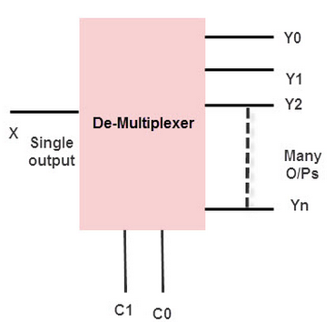

1-4 De-multiplexers
The 1-to-4 demultiplexer comprises 1- input bit, 4-output bits and – control bits. The 1X4 demultiplexer circuit diagram is shown below.
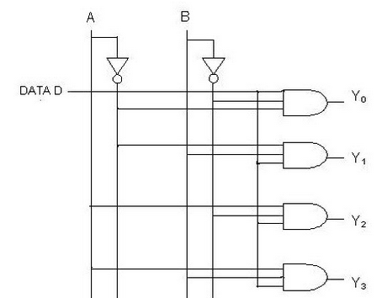
The i/p bit is considered as Data D. This data bit is transmitted to the data bit of the o/p lines, which depends on the AB value and the control i/p.
When the control i/p AB = 01, the upper second AND gate is permitted while the remaining AND gates are restricted. Thus, only data bit D is transmitted to the output and Y1 = Data.
If the data bit D is low, the output Y1 is low. IF data bit D is high, the output Y1 is high. The value of the output Y1 depends upon the value of data bit D, the remaining outputs are in a low state.
If the control input changes to AB = 10,then all the gates are restricted except the third AND gate from the top. Then, data bit D is transmitted only to the output Y2; and, Y2 = Data. . The best example of 1X4 demultiplexer is IC 74155.

Applications of Demultiplexer
Demultiplexers are used to connect a single source to multiple destinations. These applications include the following:
Communication System – Multiplexer and Demultiplexer both are used in communication systems to carry out the process of data transmission. A De-multiplexer receives the output signals from the multiplexer; and, at the receiver end, it converts them back to the original form.
Arithmetic Logic Unit – The output of the arithmetic logic unit is fed as an input to the De-multiplexer, and the o/p of the demultiplexer is connected to a multiple registers. The output of the ALU can be stored in multiple registers.
Serial to Parallel Converter – The serial to parallel converter is used to reform parallel data. In this method, serial data are given as an input to the De-multiplexer at a regular interval, and a counter is attached to the demultiplexer at the control i/p to sense the data signal at the demultiplexer’s o/p. When all data signals are stored, the output of the demultiplexer can be read out in parallel.

